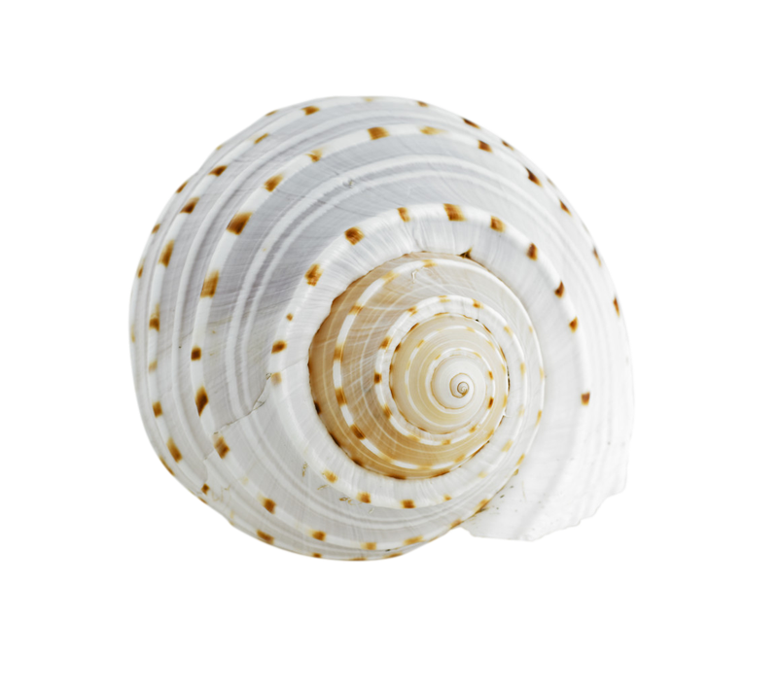

*Tour of the IS 5/24

*Math test 5/24

*Science test 5/26

*Biography Museum 5/27, doors open to parents and guests at 10:45. **Please send in a parent pick up note on the morning of the 27th, if you wish to have your child leave school at 11:15, with you.**

*No School Monday, May 30th

Story: The Albertosaurus Mystery Last day of story is Monday

Spelling Pattern: Words with /j/ and /s/

**LAST SPELLING Test: 5/24**

For the remainder of the year we will be taking several days to preview the remaining stories in our Journeys book.

*15-5 Drawing a Picture

*Review Topic 15 Tuesday

*Test Topic 15 Wed.

*Area of Squares & Rectangles

Important Dates:

dsd

**Mrs. Hudson’s Classroom News**\*

### Math

# Language Arts:

Dinner Discussions:

*On 5/24 we will be taking a tour of the IS. We will not be eating lunch there, we will return in time for lunch at Hopewell.

*Next week is our last week for grades. In order to get in the required assessments before the holiday break, we will be having a math test, science test and spelling test. I have rearranged our schedule so the math and science tests do not fall on the same day.

*While the end of the year is very close and coming quickly, it is very important for the students to remain focused through next week. I know Summer Fever is setting in for all of us. However if we can remain focused through next week, we will be able to finish our last assessments strong!

*We are eagerly preparing for the Biography Museum on 5/27. Students are invited to dress as the biography person they wrote about. They are free to bring in props, to help others visualize their character. Please remember there is a no weapons policy in school and dressing up is not required. Also, please remember that if props are oversized, they may not be able to be transported on the bus.