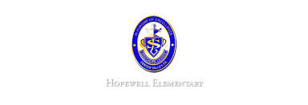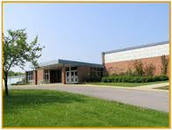

**Ask Your Child…**

* How does mass affect motion?
* Is this an example of a simple or compound sentence?

The students read the book, and the students discussed it.

* Estimate to nearest ten find the sum.

456-321

* Math: This week in math we will begin topic 3. We will learn how to add three-digit numbers as well as adding 3 or more numbers. In addition, we will review the problem-solving strategy of drawing a picture to find a solution.
* Reading: The students will continue unit 1, week 4 of Journey’s. We will be reading the story Pop’s Bridge and focusing identifying the story’s structure. We will also review how to predict and make inferences.
* Spelling Pattern: Long O. Our test will be next week!
* Science: We will review on Monday for our test on Tuesday. The study guide was sent home last Thursday. We will then begin learning about technology.
* Writing: The students will be learning how to write a narrative piece. We will focus of the voice-writing trait.
* October 25: Field Trip *must bring bagged lunch
* October 28: Halloween Parade at 2:00 PM

**Upcoming Events**

October 17, 2016

Team 19

Mrs. Pompella’s Classroom News