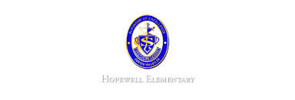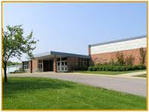

* November 29: Wear Red, White and Green for ornament decorating
* December 23-January 2: Winter Break (no school)

**Ask Your Child…**

* What **two** hemispheres do you live in?
* Give an example of a present-tense action verb.
* Give an example of a sequence of event signal word.

.

* Math: This week in Math the students will begin learning their math facts. They will learn how to multiply by 2, 5, 9, 0 and 1. They will also learn to look for patterns in their math facts. **Flashcards will be sent home on TUESDAY. Students should practice their facts each night to build fluency. Remember to sign their agendas or they will owe 5 minutes of recess to practice their facts!**
* Reading: The students will begin unit 2, week 2 of Journey’s. We will be reading the story What Do Illustrator’s Do? and focusing on how to identify and understand cause and effect using domain-specific vocabulary. We will review the signal words they may see. In addition, we will review how to analyze and evaluate as we read.
* Phonics: Words with Three-Letter Clusters (scr, spr, str, thr)
* Spelling Pattern: Three-Letter Clusters. **Test next week.**
* Social Studies: The students will continue their study of geography. They will learn about the continent, country and community that we live in.
* Writing: The students will be finishing a narrative writing piece. They may also begin an opinion piece.

**Upcoming Events**

November 28, 2016

Team 19

Mrs. Pompella’s Classroom News