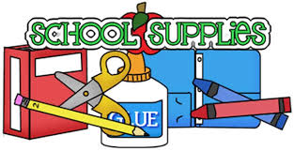

**Supply List for Third Grade**

* Ear Buds
* Small pencil box
* Glue stick
* Dry Erase Marker
* Old clean sock to erase white boards

*All folders, including a homework folder, will be supplied for your child on the first day of school. Please do not have your child bring in a 3-ring binder!

We look forward to seeing you next year! ☺

Mrs. Hudson, Mr. Bonsall, Mrs. Kale, Mrs. Scanlon and Mrs. Pompella



**Supply List for Third Grade**

* Ear Buds
* Small pencil box
* Glue stick
* Dry Erase Marker
* Old clean sock to erase white boards

*All folders, including a homework folder, will be supplied for your child on the first day of school. Please do not have your child bring in a 3-ring binder!

We look forward to seeing you next year! ☺

Mrs. Hudson, Mr. Bonsall, Mrs. Kale, Mrs. Scanlon and Mrs. Pompella