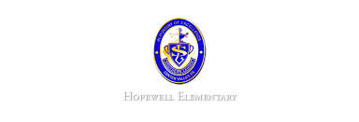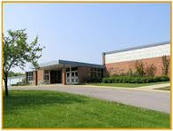

* Math: This week in math we will continue our study of topic 2. We will learn about estimating sums and differences. We will also learn about using mental math to add as well as learning to make sense of addition and subtraction equations.
* Reading: The students will begin unit 2, week 3 of Journey’s. We will be reading the story Destiny’s Gift and focusing identifying the story’s message. We will also learn how to analyze and evaluate the text.
* Spelling Pattern: VC_e. Test next week!
* Science: We will continue our unit of study of forces and motion. We will study how forces can affect motion.
* Writing: The students will be learning how to write a narrative piece. We will focus of the voice writing trait.

**Ask Your Child…**

* Give an example of the associative property of addition.
* Give an example of a position word.
* What is the simple subject in the following sentence?

The students worked on their homework.

* October 4: Picture Day
* October 7-10: Students Do Not Report
* October 13 5:30-7:00 PM: Open House

**Upcoming Events**

October 3, 2016

Team 19

Mrs. Pompella’s Classroom News