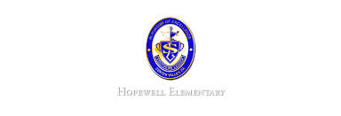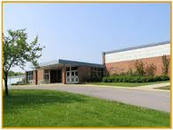

* Math: This week in math the students will continue learning about place value. We will discuss numbers on a number line as well as how to compare and order numbers. The first math test will be next Tuesday (9/20). Students will receive the study guide on Friday and can begin studying this weekend.
* Reading: The students will continue lesson one. We will be reading the story A Fine, Fine School. We will focus on story structure while reading. We will also learn about using context clue.
* Spelling Pattern: VCCV pattern. **Test this THURSDAY, September 15, 2016!**
* Science: We will continue our first topic in Science this week. We will learn the ways scientists answer questions. We will also discuss how scientists communicate with each other.
* Writing: The students will be learning how to use evidence in their writing to support*.*

**Ask Your Child…**

* Name the number 4,200 in two ways.
* How can using text evidence help improve your answer?
* Open House: Date To Be Announced

**Upcoming Events**

September 12, 2016

Team 19

Mrs. Pompella’s Classroom News